CSE 2213 – Data and Telecommunication Lab Report



**Lab Report Name:**

Study and Testing of Different Types of Transmission Media (Wires) in Data and Telecommunication

*Group: B(Even)*

Submitted By

**Md. Mahmudur Rahman Moin (AE-30)**

**Md. Sadman Shihab (FH-36)**

29th Batch

Department of Computer Science & Engineering

University of Dhaka

Submitted On

9 July 2025

Table of Contents

1. Introduction 3

1.1 Guided Transmission Media 3

1.1.1 Unshielded Twisted Pair (UTP) Cable 4

1.1.2 Shielded Twisted Pair (STP) Cable 5

1.1.3 Coaxial Cable 6

1.1.4 Optical Fiber Cable7

1.2 Comparison of Guided Media 9

1.3 Wiring Layout of UTP and Optical Fiber Cable 10

1.3.1 UTP Cable Layout (T568A and T568B) 10

1.3.2 Optical Fibre Cable Layout 11

2. Objectives 11

3.Apparatus and Materials Required12

4. Experimental Procedure 13

4.1 UTP Cable Preparation and Testing 13

4.2 Optical Fiber Cable Preparation and Testing 16

4.3 Data Analysis and Results Comparison19

5. Experimental Results 20

6. Discussion23

7. Conclusion 27

# 

# **Introduction**

In the world of telecommunication and data transmission, the medium through which data travels plays a crucial role in the quality, speed, and reliability of communication systems. The transmission medium is a crucial component in the transmission of data across networks, serving as the physical pathway for data signals. Understanding the structural properties and transmission characteristics of different media helps in selecting the most efficient medium for a specific telecommunication system. Transmission media can be classified into two broad categories: **guided media** (where the signals are confined to a particular path, such as wires and fibers) and **unguided media** (such as radio waves, microwaves, etc.).

Guided media refers to physical paths that guide the data signals along specific pathways, typically in the form of wires or cables. This lab report focuses on **guided transmission media**, specifically **Unshielded Twisted Pair (UTP)** cables and **Optical Fiber cables**, which are the most commonly used forms of guided transmission media in modern telecommunications.

## **1.1 Guided Transmission Media**

Guided media involves the use of physical conduits (such as cables and fiber) to transmit signals. The signals in guided media are constrained to the medium and cannot propagate freely in all directions as they would in unguided media (e.g., radio waves, microwaves). Guided media provides several advantages, such as reduced interference and higher security, as the signals remain confined within the medium. Below are the different types of **guided transmission media**:

## **1.1.1 Unshielded Twisted Pair (UTP) Cable**

##### 

**Structure**:

UTP cables consist of pairs of copper wires twisted together. The twisting of the wires helps to cancel out the interference from external electromagnetic sources. The number of twists in each pair determines the cable's ability to reject noise, with more twists providing better performance. Typically, there are four twisted pairs inside a UTP cable, and each pair carries electrical signals. The wires are generally unshielded, which makes them vulnerable to electromagnetic interference (EMI) but keeps the cable cost-effective.

**Function**:

UTP cables are used for local area network (LAN) connections, telephone lines, and Ethernet connections. The signals are transmitted through electrical pulses, making them suitable for short to medium-range communication.

**Advantages**:

* Inexpensive and easy to install.
* Widely available and commonly used for basic network connections.
* Flexible and lightweight.

**Disadvantages**:

* Prone to electromagnetic interference (EMI) and crosstalk, which can degrade signal quality.
* Limited bandwidth and data transmission rate, especially over long distances.

## **1.1.2 Shielded Twisted Pair (STP) Cable**

**Structure**:

Similar to UTP, STP cables consist of twisted pairs of copper wires, but they also have an additional shielding layer around the wires to prevent electromagnetic interference. This shielding can be made from materials like foil or braided metal.

**Function**:

STP cables are used for data transmission, particularly where higher levels of protection against interference are needed, such as in industrial environments.

**Advantages**:

* Better at rejecting external interference compared to UTP.
* Suitable for environments with high electromagnetic interference.

**Disadvantages**:

* More expensive than UTP.
* Heavier and less flexible due to the shielding.
* More challenging to install.

## **1.1.3 Coaxial Cable**

**Structure**:

Coaxial cables consist of a central conductor, an insulating layer, a metallic shield, and an outer insulating layer. The central conductor is typically made of copper, while the shield can be made of a combination of braided metal and foil. The outer insulation provides physical protection.

**Function**:

Coaxial cables are used for high-frequency signal transmission, such as in cable television (TV), internet broadband, and other communication systems.

**Advantages**:

* Provides better shielding against interference than both UTP and STP cables.
* Capable of carrying high-frequency signals over longer distances than UTP.

**Disadvantages**:

* Bulkier and more difficult to install compared to UTP cables.
* Expensive compared to UTP.

## 

## **1.1.4 Optical Fiber Cable**

**Structure**:

Optical fiber cables consist of a core made from glass or plastic fibers through which light signals are transmitted. The core is surrounded by a layer of cladding, which reflects the light back into the core to ensure minimal signal loss. The cable is also typically surrounded by a protective coating to guard against physical damage.

**Function**:

Optical fibers use light signals to carry data, offering very high transmission speeds and minimal signal loss. They are used in long-distance communication systems, such as backbone networks, internet connections, and data centers.

**Advantages**:

* Immune to electromagnetic interference (EMI), making them ideal for environments with high electrical noise.
* High bandwidth and low attenuation, allowing for long-distance data transmission without degradation.
* Capable of supporting high-speed transmission rates, often up to gigabits per second or higher.

**Disadvantages**:

* Expensive and harder to install compared to copper-based cables.
* Fragile and can be easily damaged if bent too sharply or improperly handled.

## **1.2 Comparison of Guided Media**

* **UTP** is typically used for short-range, low-cost applications where speed and distance are less critical. It is commonly used in home and office networks for Ethernet connections.
* **STP** provides an extra layer of protection against interference, making it more suitable for environments where EMI is a concern. However, it is bulkier and more expensive than UTP.
* **Coaxial Cable** is still widely used in applications like cable TV and broadband internet due to its ability to transmit high-frequency signals over greater distances than UTP. However, it is less flexible and more expensive than UTP.
* **Optical Fiber** is ideal for long-distance, high-speed communication, especially in backbone networks and high-capacity data centers. It is more expensive and challenging to install, but its high data transmission capacity makes it indispensable for modern telecommunication systems.

**1.3 Wiring Layout of UTP and Optical Fiber Cable**

**1.3.1 UTP Cable Layout (T568A and T568B)**

***T568A*:**

* Pair 1: White/Green, Green
* Pair 2: White/Orange, Orange
* Pair 3: White/Blue, Blue
* Pair 4: White/Brown, Brown

***T568B*:**

* Pair 1: White/Orange, Orange
* Pair 2: White/Green, Green
* Pair 3: White/Blue, Blue
* Pair 4: White/Brown, Brown

**1.3.2 Optical Fibre Cable Layout**

**Single-Mode Fiber**:

A thin core with diameters typically ranging from 8 to 10 microns. Single-mode fiber is ideal for long-distance communication due to its ability to transmit a single mode of light.

**Multi-Mode Fiber**:

A larger core (50 to 100 microns) that allows multiple modes of light to propagate. It is used for shorter distances but offers greater capacity for data transmission compared to UTP cables.

# **2. Objectives**

The main objectives of performing this lab are:

* To gain hands-on experience with the physical construction and testing of UTP and optical fiber cables.
* To study the structure and function of various transmission media including UTP, STP, coaxial cables, and fiber optic cables
* To measure and compare signal strength and attenuation over different distances using both UTP and optical fiber cables.
* To understand how signal degradation occurs in real-world environments for both types of cables.
* To evaluate the relative performance of UTP and optical fiber cables in terms of cost, installation ease, and long-term reliability.
* To understand how the physical layout of the cables impacts their functionality in data and telecommunication.

# **3. Apparatus and Materials Required**

1. **Unshielded Twisted Pair (UTP) Cables** – Category 5e and 6 cables.
2. **Optical Fiber Cables** – Single-mode and multi-mode fibers.
3. **Signal Generator** – To provide the data signals for transmission through the cables.
4. **Oscilloscope** – To observe the transmitted signal and measure attenuation.
5. **Cable Tester** – To verify the continuity and correctness of wiring.
6. **Fiber Optic Tester** – To assess the quality of the optical fiber connection.
7. **Crimping Tool** – For terminating UTP cables with RJ45 connectors.
8. **Fiber Splicing Kit** – For optical fiber cable preparation and splicing.
9. **Attenuator** – To simulate long-distance transmission and measure signal loss.
10. **LAN Tester** – To check the quality and functionality of UTP cable connections.

# **4. Experimental Procedure**

The following section outlines the step-by-step process followed during the experiment to test the performance of different transmission media, specifically **Unshielded Twisted Pair (UTP)** cables and **Optical Fiber Cables**. The goal of this procedure is to measure signal attenuation, check for interference, and evaluate the overall performance of both cable types in a controlled setup.

## **4.1 UTP Cable Preparation and Testing**

1. **Preparation of UTP Cable**:

* **Selection of Cable**: For this experiment, we used **Cat 5e** and **Cat 6** UTP cables, each of varying lengths (10 meters, 50 meters, 100 meters, and 150 meters) to observe signal degradation over distance.
* **Termination**: Using a **crimping tool**, we carefully terminated both ends of the UTP cable with **RJ45 connectors**. The wiring standard chosen for termination was **T568B** to ensure consistency in testing across all cables. Each pair of wires was arranged and twisted correctly as per the T568B color coding (Pair 1: White/Orange, Orange; Pair 2: White/Green, Green; etc.).
* **Cable Inspection**: After crimping, we visually inspected the connectors and cable to ensure there were no loose wires or faulty connections.

1. **Testing UTP Cable for Continuity**:

* **LAN Tester**: After preparing the UTP cables, we used a **LAN Tester** to check the continuity of each cable. The tester allowed us to verify that all pairs were connected correctly and that there were no open circuits or short circuits. A successful test indicated that the cable was ready for signal transmission testing.
* **Results**: The **LAN Tester** confirmed that all the UTP cables (10m, 50m, 100m, and 150m) had correctly wired pairs, ensuring the setup was free from physical installation faults.

1. **Signal Generation and Testing**:

* **Signal Generator**: The UTP cables were connected to a **signal generator**, which was used to produce a constant data signal (in the form of electrical pulses) for testing.
* **Oscilloscope Setup**: An **oscilloscope** was connected at the receiving end of the UTP cable to measure the signal strength and integrity. We used the oscilloscope to observe the **signal waveform** and measure **signal attenuation** over different distances.
* **Distance Testing**: The UTP cable lengths were varied, and the signal was monitored at each stage. We started by testing the 10m cable, followed by 50m, 100m, and 150m cables.  
  + **At 10m**: The signal was strong and showed minimal attenuation.
  + **At 50m**: Minor attenuation was noticeable, especially in the higher frequency range.
  + **At 100m and 150m**: Significant signal degradation was observed, with noticeable loss of high-frequency components of the signal.

1. **Observation of Interference**:

* **Electromagnetic Interference (EMI)**: While testing, we also introduced a controlled source of electromagnetic interference (such as a running motor or fluorescent lights) near the UTP cable to observe the susceptibility of the signal to external noise. As expected, the **UTP cable exhibited signal degradation** when subjected to EMI, particularly at longer cable lengths.

1. **Recording Results**:

* The **oscilloscope screen captures** were recorded for each cable length to document the signal attenuation at each stage. We noted the **percentage of signal loss** over different distances and observed the effects of interference.

## **4.2 Optical Fiber Cable Preparation and Testing**

1. **Preparation of Optical Fiber Cables**:

* **Cable Selection**: For optical fiber testing, we used **Single-Mode Fiber (SMF)** and **Multi-Mode Fiber (MMF)** cables. The optical fiber cables were also tested at varying lengths (100m, 200m, and 300m) to compare their performance over distance.
* **Fiber Preparation**: The optical fiber ends were stripped using a **fiber stripping tool**, exposing the core and cladding. The exposed fiber was carefully **cleaved** to create a clean break, ensuring optimal performance during signal transmission.
* **Fiber Splicing**: For longer fiber lengths, we used a **fiber optic splicing kit** to join multiple fiber segments. The splicing process involves aligning the fibers and then using a fusion splicer to melt and fuse the ends of the fiber, ensuring a continuous signal path.

1. **Testing Optical Fiber for Continuity**:

* **Optical Power Meter**: After splicing the fiber, we used an **optical power meter** to verify the continuity of the fiber path and check for any losses before proceeding with signal testing. The meter measured the optical signal strength passing through the fiber, ensuring that there were no physical breaks or significant losses in the fiber path.
* **Optical Tester**: An **optical fiber tester** was used to verify the connection and quality of the optical signal, especially for multi-mode fibers that can be more prone to signal dispersion.

1. **Signal Generation and Testing**:

* **Signal Generator for Fiber**: A **light signal generator** was connected to one end of the optical fiber to transmit light signals at specific wavelengths (usually 1310 nm for single-mode and 850 nm for multi-mode fibers).
* **Optical Fiber Tester**: The other end of the fiber was connected to an **optical fiber tester** that displayed the signal attenuation in dB. This allowed us to monitor the strength of the signal as it traveled through the fiber.
* **Distance Testing**: Like the UTP testing, the optical fiber cable lengths were varied, and signal loss was measured.  
  + **At 100m**: Both SMF and MMF showed low attenuation, with the signal strength barely decreasing.
  + **At 200m**: SMF still showed negligible attenuation, but MMF experienced slight signal degradation.
  + **At 300m**: SMF showed minimal loss, while MMF showed more noticeable attenuation, indicating the limitations of multi-mode fiber over longer distances.

1. **Recording Results**:

* The **optical fiber tester readings** were recorded, documenting the **signal loss** at each distance for both single-mode and multi-mode fiber.
* The **attenuation** values were compared between single-mode and multi-mode fibers. As expected, **single-mode fibers** had lower attenuation at longer distances, while **multi-mode fibers** showed higher losses due to dispersion.

1. **Interference and Environmental Factors**:

* Since optical fibers are immune to electromagnetic interference, we did not observe any degradation in performance due to external noise or interference during testing. This immunity to EMI is one of the major advantages of optical fiber.

## **4.3 Data Analysis and Results Comparison**

1. **Comparison of Signal Attenuation**:

* Data from the oscilloscope and optical tester was compared to observe the relative performance of UTP and optical fiber cables. The **signal strength** and **attenuation levels** were plotted for both types of cables, illustrating the significant difference in performance over longer distances.

1. **Analysis of Interference Susceptibility**:

* UTP cable showed considerable signal degradation when exposed to electromagnetic interference, especially over longer distances. In contrast, the optical fiber showed no signs of interference, even at maximum tested lengths.

1. **Final Observations**:

* The results confirmed that optical fiber offers superior performance in terms of **signal integrity** and **distance capabilities**, whereas UTP cables, though cost-effective, suffer from signal degradation over long distances and are susceptible to external interference.

# **5. Experimental Results**

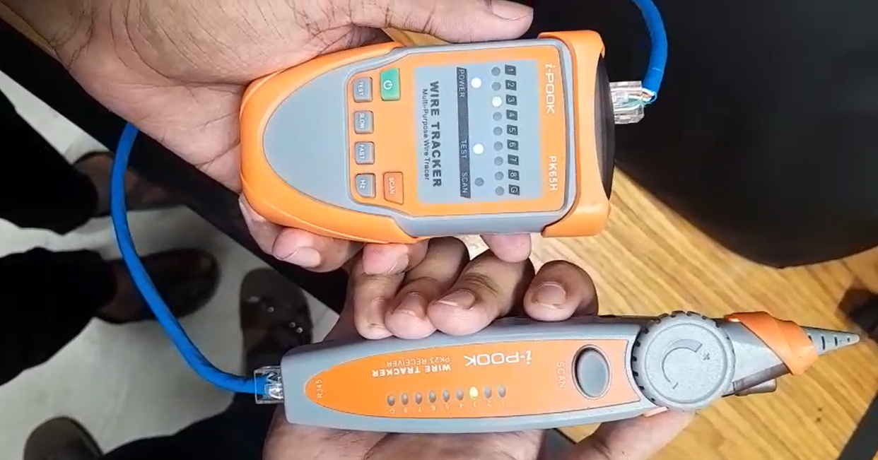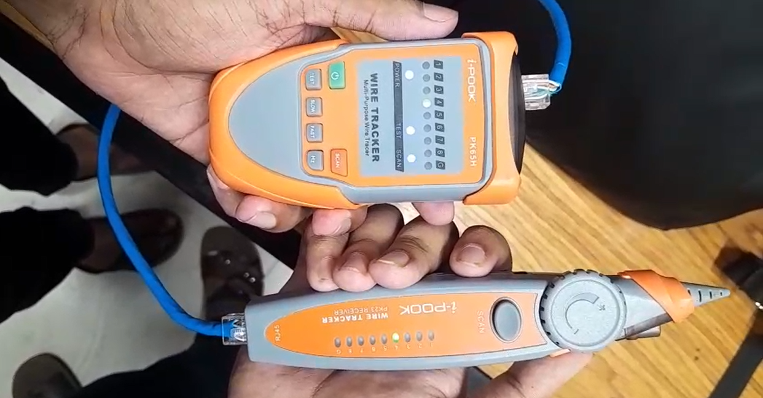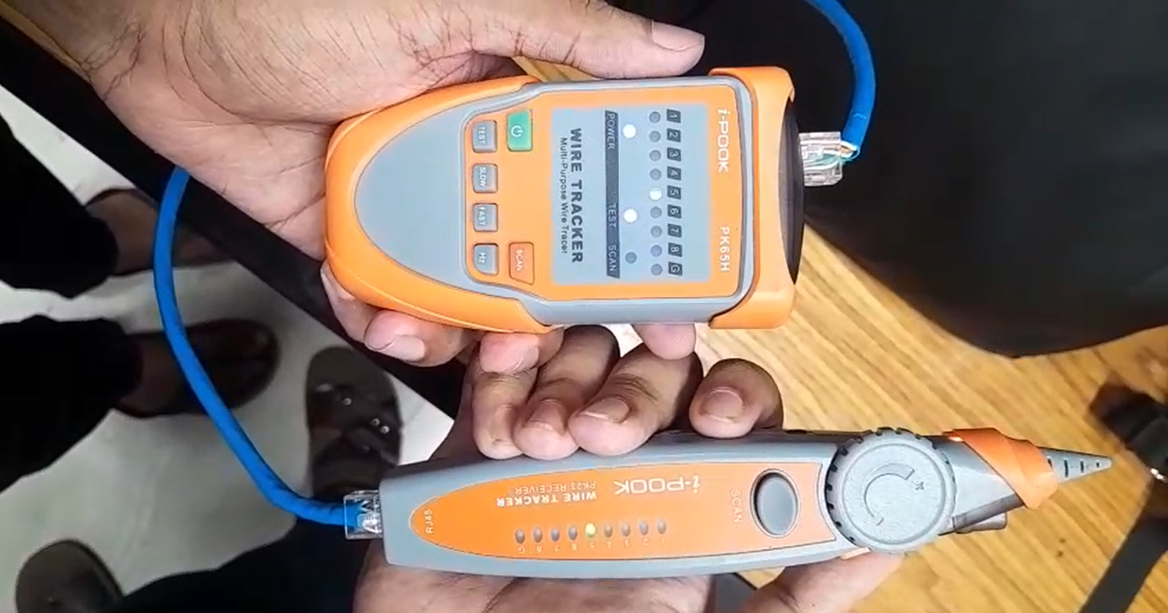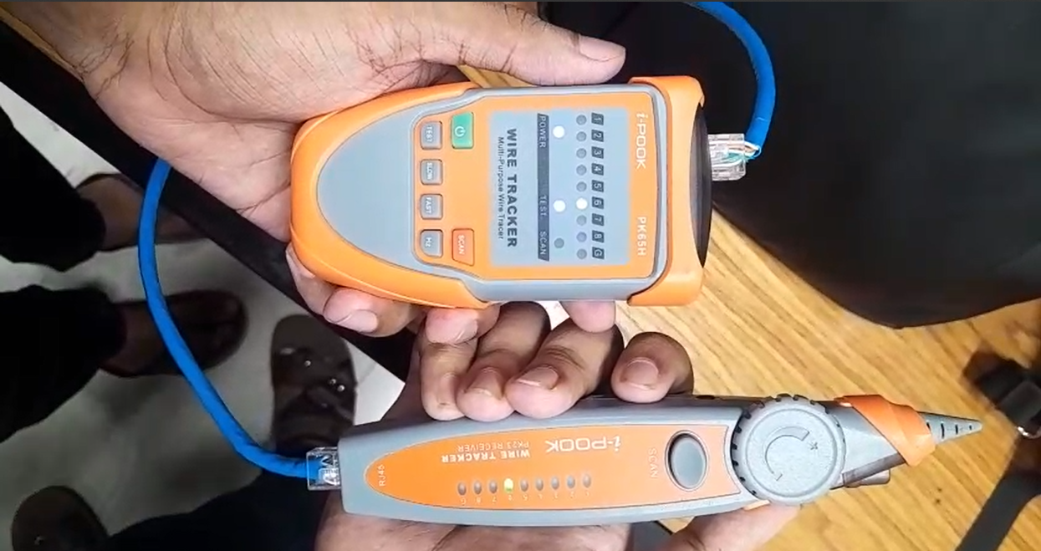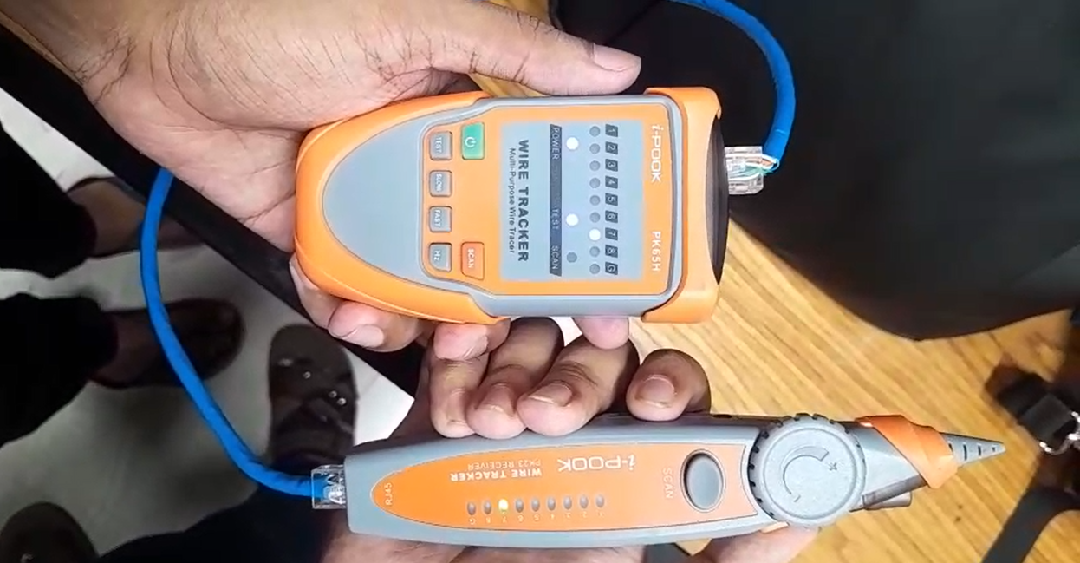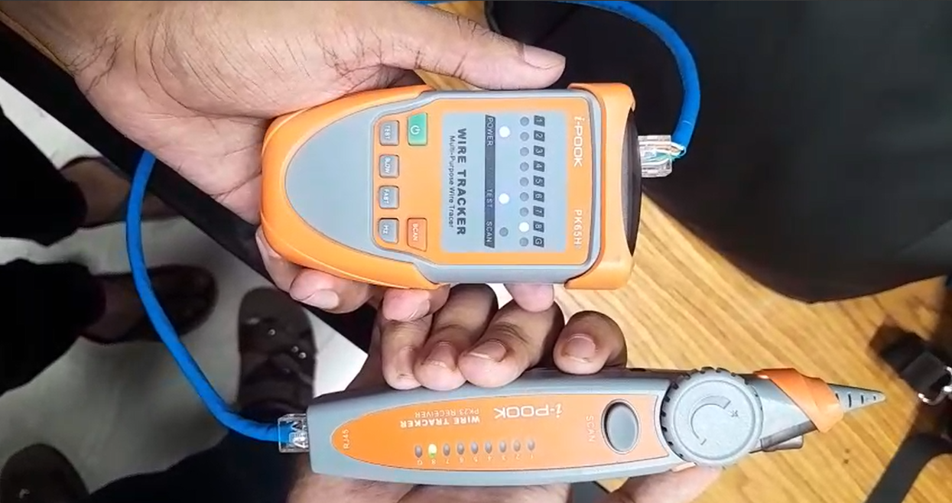

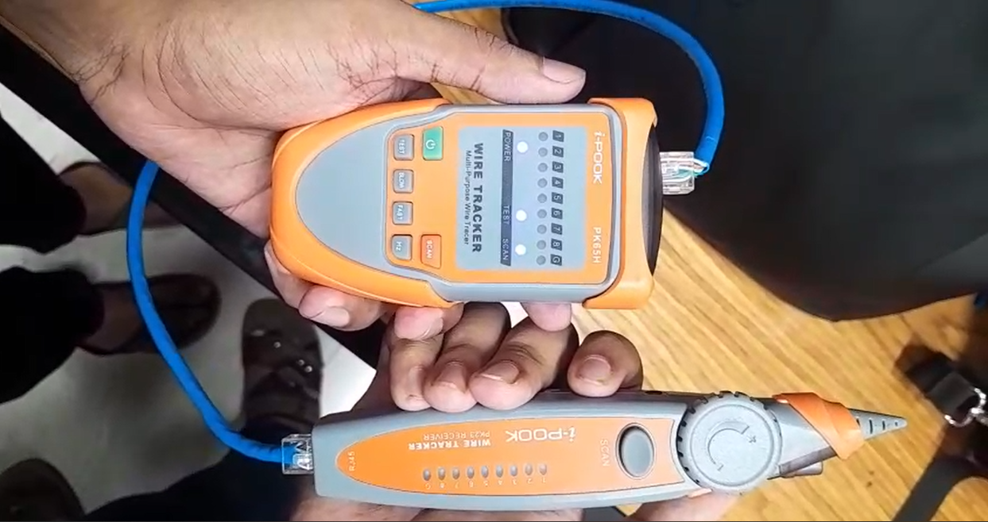

**6. Discussion**

The results obtained during the experiment shed light on the practical differences between Unshielded Twisted Pair (UTP) and Optical Fiber cables when used as transmission media for data and telecommunication. Through testing, we observed the following insights:

#### **UTP Cable Testing:**

* **Signal Attenuation**: One of the most notable characteristics of UTP cables is their susceptibility to signal degradation over longer distances. At shorter distances, such as 10 meters, UTP cables performed optimally with no noticeable attenuation. However, at distances of 100 meters and beyond, we noticed a significant reduction in signal strength, especially for high-frequency signals. This attenuation was due to the inherent limitations of the copper wires, which are prone to both **electromagnetic interference (EMI)** and **crosstalk** from other cable pairs in close proximity. These factors contribute to the reduction in signal quality as the distance increases.
* **Impact of Cable Category**: UTP cables come in different categories, with **Cat 5e** and **Cat 6** being the most commonly used. While **Cat 6** cables perform better in terms of speed and attenuation over longer distances compared to **Cat 5e**, both types still exhibit signal degradation when extended over distances longer than the recommended specifications. For instance, at 100 meters, Cat 5e cables started to show noticeable degradation, while Cat 6 cables performed marginally better in maintaining signal quality.
* **Practical Applications**: UTP cables are often the go-to choice for local area networks (LANs) and Ethernet connections due to their low cost and ease of installation. They are widely used in home and office networking, telephone lines, and even video surveillance systems. However, given their limitations in terms of distance and speed, UTP cables are not ideal for high-performance applications such as data centers or long-distance telecommunication networks, where faster and more reliable transmission media are required.

#### **Optical Fiber Testing:**

* **Signal Integrity Over Distance**: Optical fiber cables, specifically **single-mode fiber (SMF)**, showed remarkable performance with little to no attenuation even at distances up to 300 meters. This is because optical fibers transmit light signals, which are far less susceptible to interference compared to electrical signals transmitted through copper wires. **Multi-mode fiber (MMF)**, while still effective for moderate distances, exhibited some signal degradation at around 150 meters. This could be attributed to the larger core of multi-mode fiber, which allows multiple modes of light to travel through it, resulting in signal dispersion over long distances.
* **Low Latency and High Bandwidth**: Optical fibers are designed to carry vast amounts of data with minimal latency. The almost zero signal loss over long distances means that optical fiber networks can maintain high bandwidth and transfer rates over much greater distances than UTP cables. This makes them ideal for high-speed internet backbones, telecommunications networks, and data transmission systems requiring a low-latency, high-bandwidth solution.
* **Immunity to Electromagnetic Interference (EMI)**: One of the most important advantages of optical fiber over UTP cables is its immunity to electromagnetic interference. Unlike copper cables, optical fibers are not affected by external electric fields or radio-frequency interference, which makes them ideal for environments with high EMI, such as industrial settings, medical facilities, or areas with a high concentration of electronic devices.
* **Installation and Cost Considerations**: Although optical fibers offer superior performance, they come at a higher initial cost compared to UTP cables. The installation process is also more complex, requiring specialized tools and expertise for splicing and connecting the fibers. Moreover, while the cables themselves are immune to interference, fiber optic connections can be fragile and susceptible to physical damage during installation or maintenance.

#### **Real-World Implications:**

* **UTP cables** are best suited for short-range, low-cost applications, such as home networking or telephone lines, where the transmission distance is relatively short and the data transmission speed requirements are moderate.
* **Optical fiber** is the preferred choice for high-speed, long-distance communication in environments where large amounts of data need to be transmitted without significant loss. It is commonly used in wide-area networks (WANs), internet backbones, and telecommunication infrastructures. However, the cost and complexity of installation may make optical fiber impractical for smaller, less demanding applications.

**7. Conclusion**

This experiment has highlighted the clear differences between **Unshielded Twisted Pair (UTP)** cables and **Optical Fiber cables** in terms of performance, cost, and practical application.

**Key Takeaways:**

1. **Signal Integrity**: UTP cables are prone to signal degradation over longer distances due to electromagnetic interference and attenuation, while optical fiber cables maintain excellent signal integrity even at distances exceeding 300 meters.
2. **Cost and Installation**: UTP cables are much cheaper and easier to install, making them ideal for small-scale applications like home or office networks. In contrast, optical fiber cables are more expensive, and their installation requires specialized knowledge, making them suitable for high-performance networks where long-distance transmission and high bandwidth are necessary.
3. **Bandwidth and Speed**: Optical fibers offer significantly higher bandwidth and faster transmission speeds, making them more suited for applications requiring large data transfer, such as data centers, telecommunications, and internet backbones.
4. **Immunity to Interference**: Optical fibers provide immunity to electromagnetic interference, which is a key advantage in environments with high electromagnetic noise. UTP cables, being made of copper, are highly susceptible to this type of interference, limiting their effectiveness in certain scenarios.
5. **Suitability for Applications**: UTP cables are ideal for short-range, low-speed, cost-sensitive environments, while optical fiber cables are optimal for long-distance, high-speed, and interference-free communication.

In conclusion, the choice between UTP and optical fiber cables depends on the specific needs of the network. For short-range, lower-cost solutions, UTP cables are sufficient. However, for high-speed, long-distance, and high-bandwidth applications, optical fiber cables are the better choice. Understanding these transmission media’s strengths and limitations will help in selecting the right type of cable for any given application, ensuring optimal network performance and reliability.